LaserCut

2017

**Laser Engraving & Cutting Control System**

**Manual**

V0.1

Janurary, 2017

**Content**

**Content-----------------------------------------------------------------------------------------------2**

1 1 System Installation 3

1.1 Contents of the Control System 3

1.2 Installation of the System 3

2 Details of software operation 8

2.1 Overview of the software interface 8

2.2 Definition and details of the shortcut icons 8

2.3 Definition and details of techics tools 27

2.4 Set Processing Parameters 29

2.5 Definition and details of the icons on processing interface 34

2.6 Machine Setting 38

2.7 Version Check and Upgrade 46

2.8 Description of status bar 46

3 Appendixes 47

3.1 Quick Operation 47

3.2 Cutting not sealing 48

3.3 Backlash Adjustment in Engraving 49

3.4 FQA 50

# 1 System Installation

## Contents of the Control System

Content of the software:

|  |  |  |  |  |
| --- | --- | --- | --- | --- |
| No. | File & list | Function | Dir | Remark |
| 1 | LaserCut2017_V*.*.*.*.exe | Laser Engraving &Cutting software | ..\ | Copy this folder to the directory you need, and run LaserCut61.exe |
| 2 | Readme | Update Record | ..\ |  |

## Installation of the System

* + 1. **Installation of the controller driver**

Run LaserCut2017_V*.*.*.*.exe ，install the application

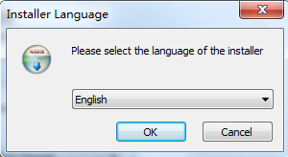

Operation according to the tips until it shows the following interface:

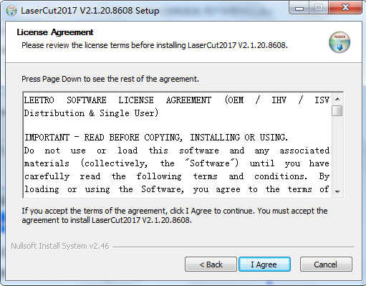

Check”I agree” and click “Install”.

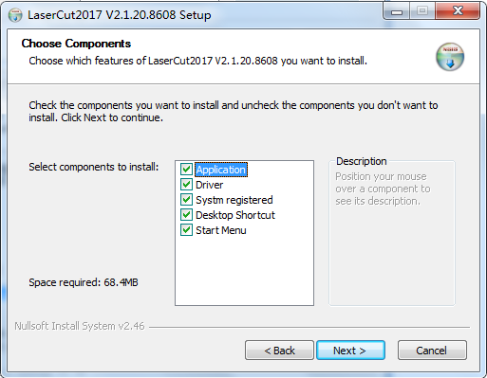

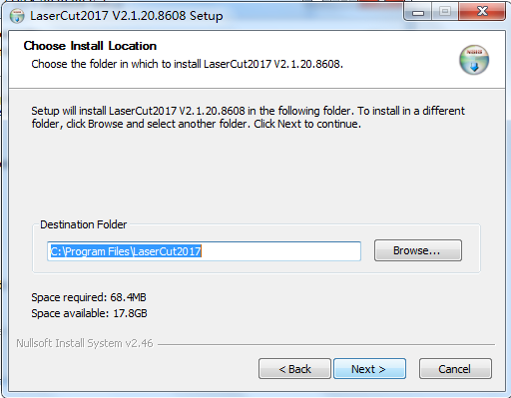

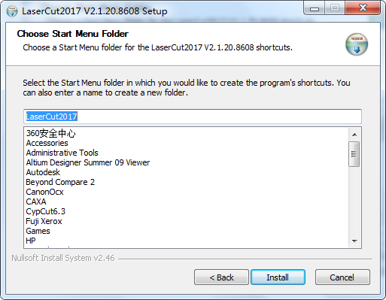

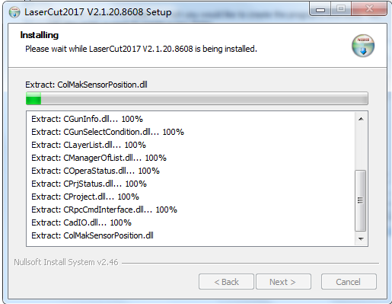

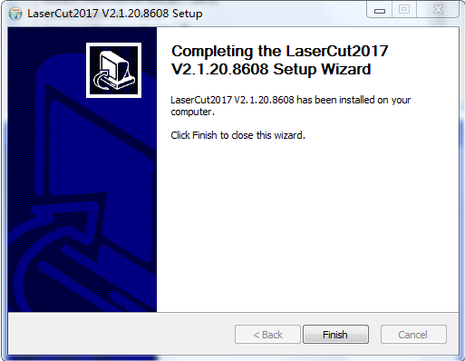

Click “Finished” and finish the installation.

Note:

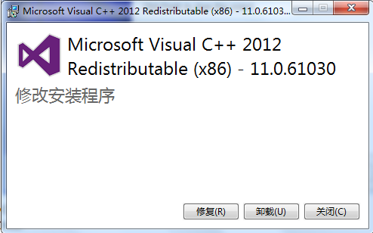

If the computer first install application software, will pop up above the frame installation, installation can be, if not the first time can be installed, click close.

# Details of software operation

## Overview of the software interface

* + 1. **Run the software**

Double click Laser2017.exe and run the software.

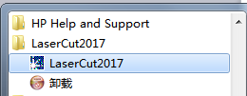

* + 1. **Main interface of the software**

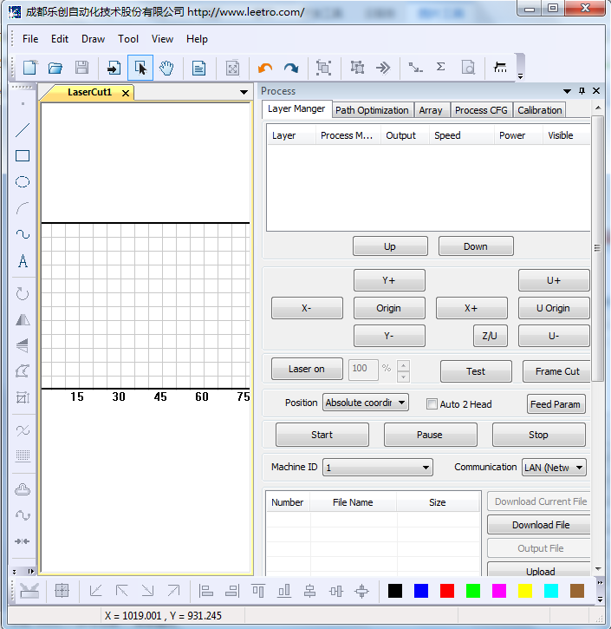

## Definition and details of the shortcut icons

|  |  |  |  |
| --- | --- | --- | --- |
| Function | Icon form | Definition | Detail |
| New |  | Create a new processing file | 2.2.1 |
| Open |  | Import a processing file (*.lcp) | 2.2.2 |
| Save |  | Save the current editing graph as a processing file (*.FTP) |
| Import |  | Import file that the software supports | 2.2.3 |
| Select |  | Switch the mouse to select status | 2.2.4 |
| Pan |  | Move the graphic display area of the software range | 2.2.5 |
| Worktable range |  | Show the whole worktable range | 2.2.6 |
| Data range |  | Show full processing data range |
| Undo |  | Return to the last edit state | 2.2.7 |
| Redo |  | Recover to the state before undo |
| Group |  | Group graph entities to one entity | 2.2.8 |
| Ungroup |  | Divide grouped entity to graph entities |
| Set start point |  | Set start point of vector graph | 2.2.9 |
| Set stop position |  | Set the stop position when process finished | 2.2.10 |
| Statistical info |  | Statistical information of the current data | 2.2.11 |
| Simulation |  | Simulate the processing trace of the current data | 2.2.12 |
| Simulate Speed |  | Adjust the Simulating speed |
| Line |  | Draw line | 2.2.13 |
| Rectangle |  | Draw rectangle | 2.2.14 |
| Ellipse |  | Draw ellipse | 2.2.15 |
| Bezier curve |  | Draw Bezier curve | 2.2.16 |
| Text |  | Input text | 2.2.17 |
| Rotate |  | Rotate the graph | 2.2.18 |
| Horizontal mirror |  | Horizontal mirror the graph | 2.2.19 |
| Vertical mirror |  | Vertical mirror the graph |
| Edit Node |  | Edit the mode of the graph | 2.2.20 |
| Size |  | Change the size of the graph | 2.2.21 |
| Invert color of Bitmap |  | Intaglio or anaglyph Bitmap file | 2.2.22 |
| Parallel lines |  | Expand or reduce the vector graph | 2.2.23 |
| Smooth curve |  | Smooth the vector graph | 2.2.24 |
| Bridge Connect |  | Break the vector graph | 2.2.25 |
| Array copy |  | Array copy the graph and the data size is large | 2.2.26 |
| Virtual array |  | Virtual array the graph and the data size is small |
| Center data |  | Move data to the center of the drawing area | 2.2.27 |
| Left lower data |  | Move data to the left lower corner of the drawing area |
| Left upper data |  | Move data to the left upper corner of the drawing area |
| Right lower data |  | Move data to the right lower corner of the drawing area |
| Right upper data |  | Move data to the right upper corner of the drawing area |
| Left alignment |  | Left align the selected graph | 2.2.28 |
| Right alignment |  | Right align the selected graph |
| Top alignment |  | Top align the selected graph |
| Bottom alignment |  | Bottom align the selected graph |
| Horizontal center |  | Horizontal center the selected graph |
| Vertical center |  | Vertical center the selected graph |
| Center alignment |  | Center align the selected graph |
| Divide Layer |  | Divide the graph to many layers as wants | 2.2.29 |

* + 1. **New**

Create a new processing file. The shortcut key is Ctrl+N.

Click on the icon to create a new file.

* + 1. **Save and Open**

Open: import a processing file (*.lcp).

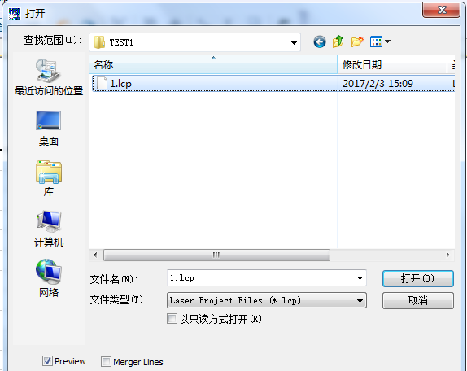

Select the file in “Search range” and click “Open” to import the saved processing file.

The processing file has processing parameters and can be processed without setting processing parameters.

Save: save the current editing graph as a processing file (*.lcp).

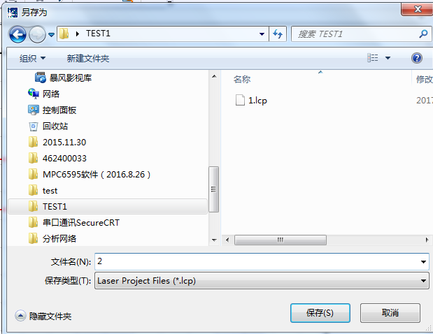

Input file name in “File name”, and click “Save” to save the graph data and processing data as a processing file (*.lcp).

* + 1. **Import**

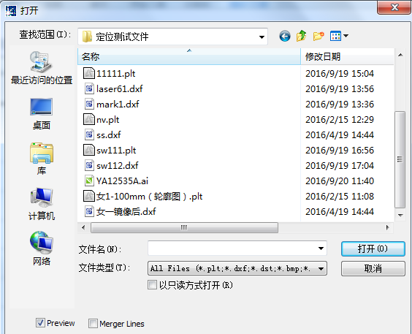

The software support many file formats, such as *.PLT、*.AI、*.DXF、*.DST、*.BMP、 etc.

The same data can be imported many times. Different data can be imported by importing many times.

* + 1. **Select** 

The short key is Shift+J.

It is default status. Press the Esc key will return to this status.

When it is on other status (such as drawing), click the icon will return to default status.

* + 1. **Pan**

Click this button, and press along the left key of mouse, drag the mouse to move the drawing area.

* + 1. **Worktable Range and Data Range** 

Short key is Shift+F4 and F4.

Worktable Range: click the button to display the full working size/coordinate system.

Data Range: click the button to display the full range of the data/selected data.

* + 1. **Undo and Recovery** 

Short key is Ctrl+Z and Ctrl+U.

Undo: return to the statue before last edit.

Recovery: recover to the statue before undo.

* + 1. **Group and Ungroup** 

Group: select the graph entities need to be grouped, click the group button, and the graph entities will be grouped.

Ungroup: select the grouped graph, and then click the ungroup button, and the graph will be disassembled to several graph entities.

* + 1. **Set Start Point** 

The system will automatically define the start point (usually the crossed point of two lines) and the direction of cutting process. Select the vector graph, click the button, move the mouse to the vector graph, and the mouse will change to a cross. Click the mouse on any position of the vector graph, the point will be the start point of cutting, and click “F” to invert the direction. It appears as below:

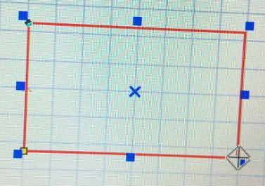

* + 1. **Set the Stop Position of the Laser Head** 

The laser head will move to the point when process finished. Click the button and the mouse arrow will change to a circle, dialog box appears as below:

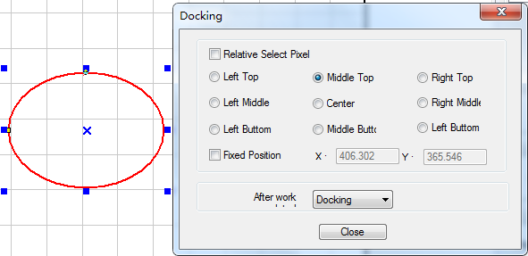

There are 4 modes: related selection, relative whole graph, fixed Position, and anywhere.

Related selection：Select part of the graph first, select the “Related Selection” option, and select relative position of the graph (i.e. Left up, Right down).

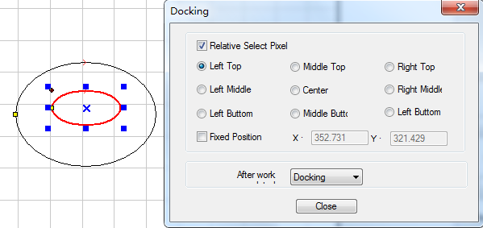

Relative whole graph: Without selecting the “Related Selection” option, and select relative position of the graph (i.e. Left up, Right down).

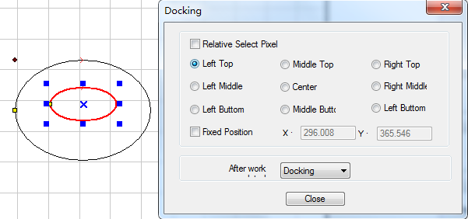

Fixed Position：Select “Fixed Pos.” and input the coordinate value to set the stop position precisely.

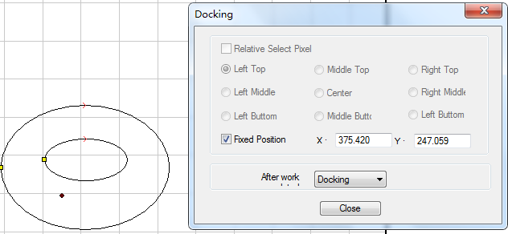

Anywhere：Move the mouse to any point and set the stop position as you need.

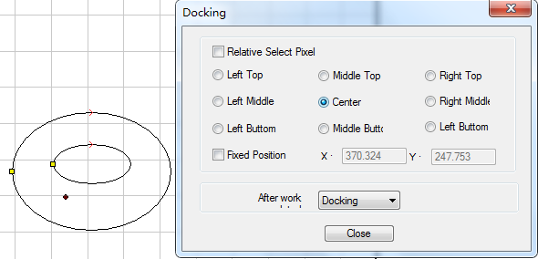

* + 1. **Statistic**

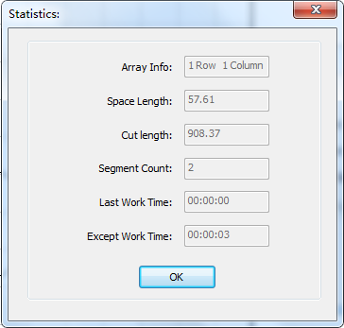

Show the processing information if current data.

The work time is inaccurate, and the work time on PAD is accurate.

* + 1. **Simulate and Simulate Speed** 

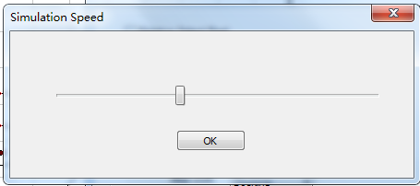

Simulate the processing trace of the current data. The simulate speed can be adjusted.

* + 1. **Line** 

After clicking the button, drag the mouse on the screen to draw a line as will. Double click the left key to finish drawing the line. Press “Ctrl” at the same time and you can draw a horizontal/vertical line.

* + 1. **Rectangle** 

After clicking the button, drag the mouse on the screen to draw a rectangle with any size. Press “Ctrl” at the same time and you can draw a square.

* + 1. **Ellipse** 

After clicking the button, drag the mouse on the screen to draw an ellipse. Press “Ctrl” at the same time you can draw a circle.

* + 1. **Bezier Curve** 

After clicking the button, drag the mouse on the screen to draw a Bezier Curve. Double click the left key to finish drawing the Bezier Curve.

* + 1. **Text** 

Click the button and drag the mouse on the screen, dialog box appears as below:

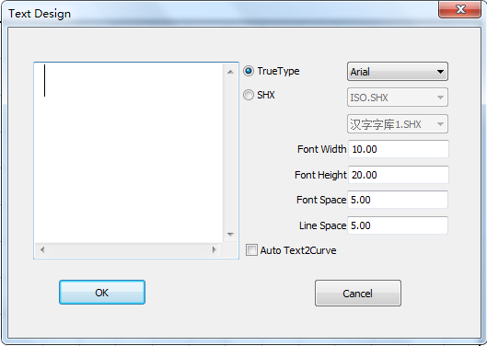

Text can’t be processed, and it has to be converted to curve (Drawing—convert to curve).

You can also set “Auto Convert Text to Curve” in Machine CFG.

* + 1. **Rotate** 

Click the select button  first to select the graph need to be rotated, and then click “Rotate” button  on the left side toolbar to rotate the graph. Dialog box appears as below:

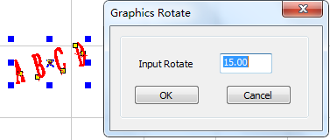

Input appropriate numbers and click “OK” to get precise rotate angle.

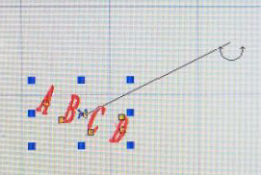

Click “Cancel” and drag the mouse to get any rotate angle.

* + 1. **Mirror** 

Click the select button 11 first to select the graph need to be mirrored, and then click the button to mirror the graph.

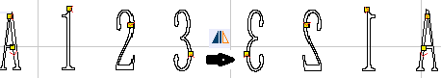

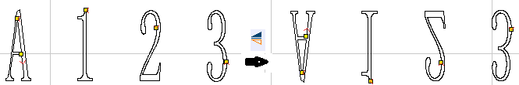

* + 1. **Edit Node**

Click the button to edit the nodes of the vector graph selected. Click the button and nods on the vector graph will be shown in the form of small box. It appears as below:

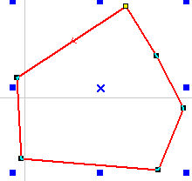

Move the mouse on the node and drag the mouse will change the shape of the graph.

When move the mouse on the graph, the mouse will change into cross, double click the mouse will add a new node. Move the mouse on the node and click “Delete” to delete a node.

* + 1. **Size** 

Click the select button 11 first to select the graph need to be changed, and click the button，dialog box appears as below:

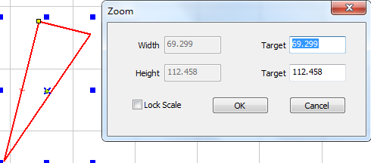

Input the target size on the X, Y axis, and click “OK” to change the size of the graph.

Select “Lock Aspect Ratio” and input the length of X or Y, and the size will change with the same proportion.

* + 1. **Invert color of Bitmap** 

Click the button to invert the color of the BMP image. The process result will be intaglio or anaglyph. It appears as below:

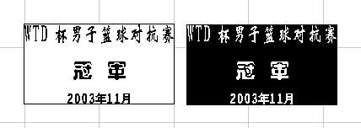

* + 1. **Parallel lines** 

This is used to expand or reduce the vector graph. Click the select button 11 first to select the graph need to be processed, and then click the button001 on the left side toolbar, dialog box appears as below:

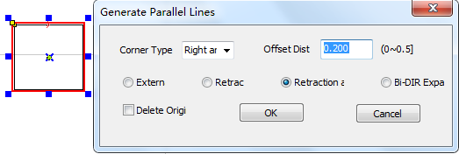

Select the needed option to generate parallel lines on a new layer. As it shows below:

Corner type can be selected as circle or sharp. Select circle, the lines will be smoother, but small distortion will be created on the corner.

* + 1. **Smooth Curve** 

When the graph smoothed, speed and stability of the cutting process will be improved. Select the data need to be processed, and click the button, dialog box appears as below:

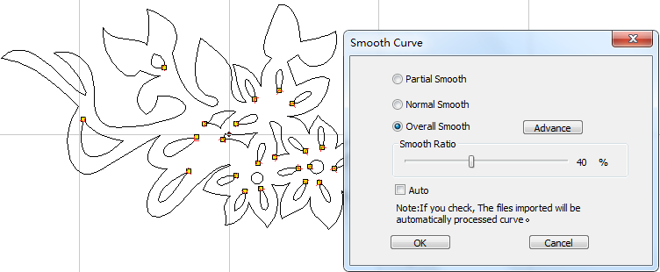

There are three levels: standard, medium and high. The graph will be deformed when smoothing.

* + 1. **Array**

**Array Copy** ：Click the select button first to select the graph need, and then click the button, dialog box appears as below:

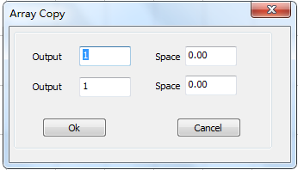

Input relevant parameters, identical graph with the number of the “lines × columns” will appear on the screen. The space between the graphs will be determined by the “Space”.

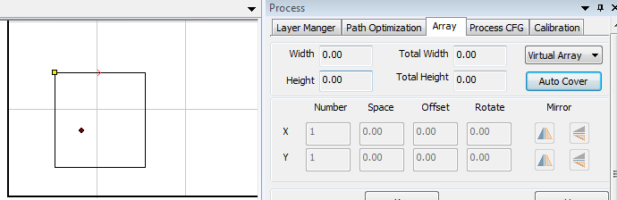

**Cell width (X)**: original size of the graph.

**Cell height (Y)**: original size of the graph.

**Times**: lines or columns needed for the output data.

**Gap**: space between neighboring lines or columns.

**Width**: width of the whole data after virtual arraying.

**Height**: height of the whole data after virtual arraying.

**Gap Along Y**: space of the dislocation between neighboring columns.

**Gap Along X**: space of the dislocation between neighboring rows.

**Absolute Gap**: if the space is 0, select “Absolute Space Mode”, and the graph will be overlapped completely.

**Y First**: the cut route will along Y direction.

**Left to Right**: define the processing sequence. Check the option and the sequence is from left to right.

**Bottom to Top**: define the processing sequence. Check the option and the sequence is from bottom to top.

**Auto-cover**: Click the button, and dialog box appears as below:

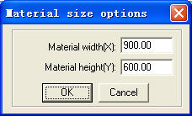

**Material Width**: width of the materials to process (default as the width of the worktable).

**Material Height**: length of the materials to process (default as the length of the worktable).

* + 1. **Quick move data** 

Corresponding icon is  on the grounded toolbar.

Move the selected data to corners of the drawing area.

* + 1. **Align** 

Corresponding icon is 001 on the grounded toolbar.

* + 1. **Divide Layer **

If the graph has many colors, system will divide it to many layers automatically.

If the graph has only one color, select some figures and click a color on the layer toolbar, and the system will divide the graph to many layers as wants.

## Definition and details of techics tools

* + 1. **Check Data**

Location: Tool Check Data.

Click the tool, and dialog box appears as below:

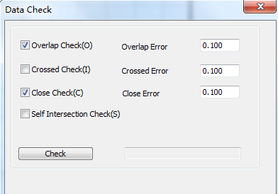

If abnormal phenomenon appears in the processing (such as fail to engrave, cut twice), use the tool to check all the data. Abnormal data checked will be shown as red. You can delete it or edit the node.

* + 1. **Unite lines**

Location: Tool Unite lines.

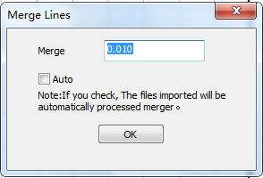

Connect lines linked end to end into one. Select lines need to be processed, and click the button will do.

* + 1. **Set Output Sequence**

**Auto sort:**

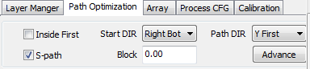

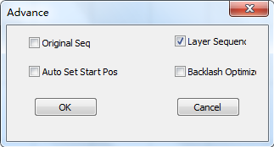

## Set Processing Parameters

* + 1. **Layer Management**

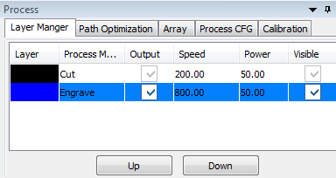

Process sequence is from the top to the bottom of the layer list. Select one line in the list and clickUP orDOWN, and the process sequence will be changed.

Process mode can be selected in the drop-down list of the “Mode” column. It shows as below:

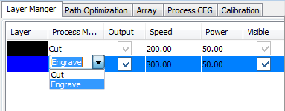

Output the layer or not can be set in the “Output” column. output1 is output and output2 is not.

Double click one line in the list and set processing parameters.

* + 1. **Set Cut Parameters**

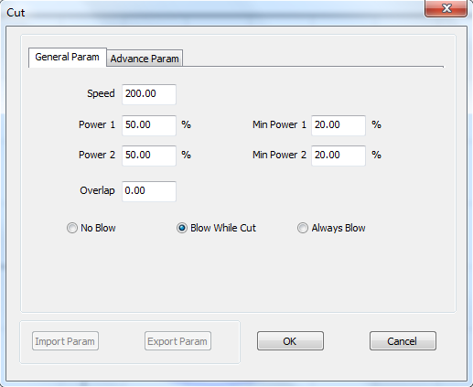

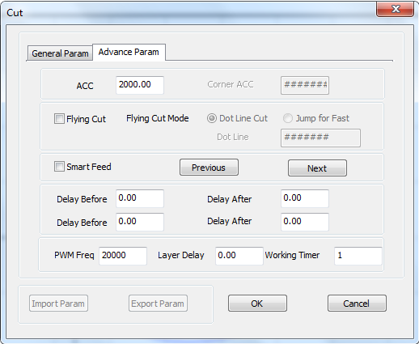

|  |  |  |
| --- | --- | --- |
| Parameter | Representative value | Description |
| Work Speed | 100 | Set according to the power value of the laser and the processing material |
| Overlap Length | 0 | If closed graph can't be cut down, this parameter should be set a proper value. If the value exceed o.5, it is suggested to adjust mechanical assemble precision to solve the problem;  It is suggest to set the backlash parameter in axis CFG to solve the problem first. |
| Work Acc | 1000 | The machine will shake when cutting begin and stop. The greater the value is and the machine shakes more intensively. |
| Power1 | 100 | The greater the value is and the laser power is greater. |
| Min Power1 | 50 | The smaller the value is and the laser power on corner is smaller. |
| Power 2 | 100 | The greater the value is and the laser power is greater. |
| Min Power 2 | 50 | The smaller the value is and the laser power on corner is smaller. |
| Blow Mode | No | This is blowing air. Choose according to need. |
| Layer Times | 1 | Set the processing times of the layer. Set according to need. |

|  |  |  |
| --- | --- | --- |
| Parameter | Representative value | Description |
| Delay before laser on | 0 | Choose according to need. |
| Delay after laser on | 0 | Choose according to need.  This parameter can be used as gas path delay. |
| Delay before laser off | 0 | Choose according to need. |
| Delay after laser of | 0 | Choose according to need. |

* + 1. **Set Engrave Parameters**

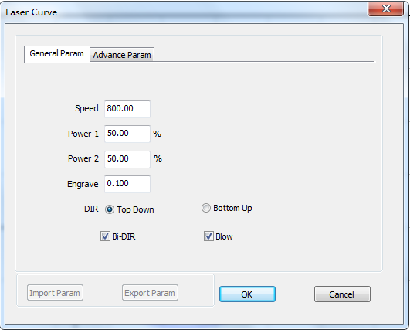

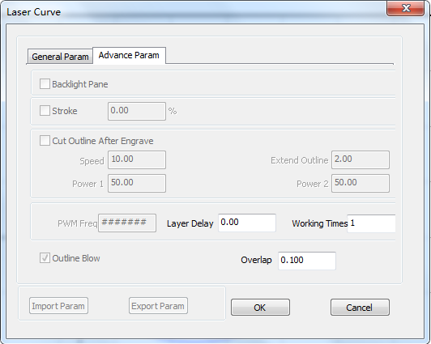

**Engrave Speed**: engraving speed on X-axis.

**Power1/2**: laser power in engraving (unit: %).

**Scan gap**: movement distance on Y-axis when engrave a row on X-axis.

**Bi-direction**: it will engrave both on positive and negative movement of X-axis when this parameter is chose. The efficiency is high, but if you need a high process precision, do not choose this option. The efficiency will be cut half.

**Engrave Blow**: blow or not, with this option selected or not.

**Direction:** this is the engrave direction.

**Layer Times**: a layer can be processed many times. Input the value as you need.

* + 1. **Process Parameters**

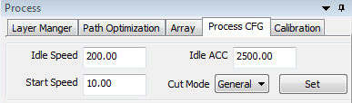

Here mainly focus on the idle speed and idle acceleration; idle speed is greater, the higher the efficiency of air, the impact of jitter and equipment more; air acceleration also associated with the device, the greater the acceleration may be idle equipment more jitter. Click on the settings button in the "process parameters"

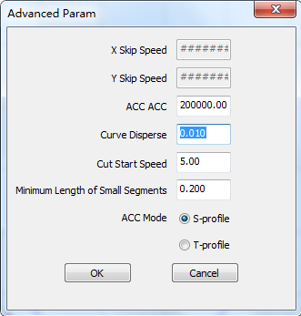

Jerk acceleration scenarios are valid in the S type discrete precision cutting effects, usually the smaller discrete precision machining effect is better, but the greater the amount of data processing. According to the actual needs, usually 0.1-0.3 can;

## Definition and details of the icons on processing interface

* + 1. **Feed Parameters**

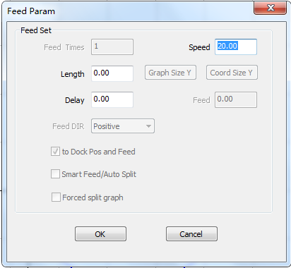

**Length**: when processing finished, Z-Axis will feed a relevant distance for the feeding of the materials.

**Delay**: the machine will delay a certain time before feeding after processing finished.

**Speed**: feeding speed of the Z-Axis.

* + 1. **Auto 2-Head**





If the machine has automatic separation function, select this option and the space between the two laser head will adjust automatically; or the space between the two laser head won’t adjust and the machine will be used as simple double laser head machine.

* + 1. **Immediately Output**

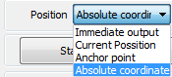

System will process the data according to their coordinate in the worktable range when the option not selected.

System will process the data from where the laser head is when the option selected. Relevant relations between the stop position and the processing data remain unchanged.

* + 1. **Selected Output**

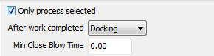

When select the option, system will only process the graph selected.

* + 1. **Frame Cut**

Set parameters of cutting the work piece well-processed off the materials.

Click the button after the process finished, dialog box appears as below:

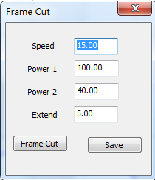

**Speed**: speed of the laser head in cutting.

**Power1/2:** power of the laser in cutting.

**Extend**: distance between processing figure and edge of the work piece cut down.

**Cut**: click the button to cut the work piece.

**Save**: click the button to save the parameter in case of the future use.

The parameters will be effective only when the processing data be re-downloaded.

* + 1. **Download File**

Click “Download” button, dialog box appears as below:

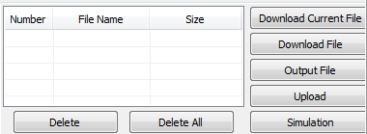

**Download Current File**: Download the current processing data to controller.

**Download File**: Download the processing files (*.NC) which have been generated to controller.

**Delete**: Delete the selected file.

**Del All**: Delete all the files in controller.

**Output File**: This will generate a *.NC or other processing file with all the well-set parameters. This file can be downloaded to controller by USB disk.

This function is the same as Download Current File. The difference is that files can be downloaded without the connection of the computer.

* + 1. **Minimum Close Blow Distance**



The main function is to avoid the equipment in the process of the design of the gas switch

* + 1. **Controller Connection**





In the file download operation according to the different needs of different types of communication mode selection board, also need to choose the number of different display controller, if the connection control card fails, you can double-click the connection control card failed to connect again.

## Machine Setting

* + 1. **Controller Parameters**

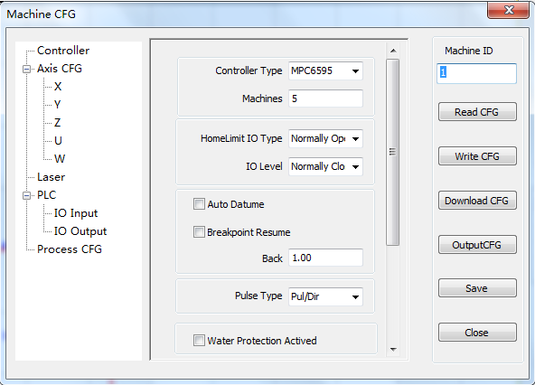

|  |  |  |  |
| --- | --- | --- | --- |
| Parameter | Respective value | | Description |
| Screw/Rack | Belt |
| Controller Type | MPC*** | MPC*** | According to the actual use of the scene |
| Machines | 1 | 1 | According to the actual use of the scene |
| HomeLimit IO Type | Normally open | Normally open | Factory set is suggested. |
| Auto Datume | Check | Check | Factory set is suggested. |
| Breakpoint Resume | Don’t Check | Don’t Check | Factory set is suggested. |
| Water Pro Actived | Don’t Check | Don’t Check | Factory set is suggested. |

* + 1. **Axis CFG**

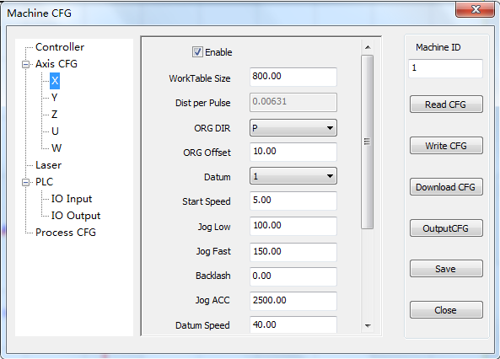

|  |  |  |  |
| --- | --- | --- | --- |
| Parameter | Respective value | | Description |
| Screw/Rack | Belt |
| WorkTable Size | *** | *** | Set according to the machine size.  Only factory set is OK. |
| Dist Per Pulse | *** | *** | Only factory set is OK. |
| ORG Dir | *** | *** | Only factory set is OK. P is Positive，N is Negative |
| ORG Offset | 10 | 10 | Factory set is suggested. |
| Datum | 1 | 1 | Factory set is suggested. |
| Start Speed | 10 | 10 | Factory set is suggested. |
| Jog Low | 40 | 60 | Factory set is suggested.  The jog speed when the machine not returns to origin. |
| Jog Fast | 60 | 100 | Factory set is suggested.  The jog speed when the machine returns to origin. |
| Backlash | 0 | 0 | Only factory set is OK.If closed graph can't be cut down, this parameter should be set a proper value. If the value exceed 0.5, it is suggested to adjust mechanical assemble precision to solve the problem. |
| Jog Acc | 600 | 1000 | Adjust the value depending on if vibration occurs when jog stops.  The greater the value is and vibration more intensive. |
| Datum Speed | 40 | 40 | Factory set is suggested. |

2.6.2.1 Gain factory set

Recover the parameters as factory set on PAD. And click the button “Upload CFG” in the machine setting interface.

2.6.2.2 Pulse Unit

It is the distance that the laser head moves when controller output a pulse. Click the value right side of the “One Pulse Move Length” and dialog box appears as below:

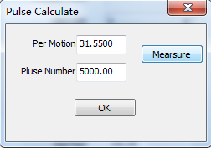

40.384001 in the picture above means the distance of the laser head moves every round of the motor is 40.384001 mm. 6400 is the pulse number every round of the motor needs.

Pulse unit can be set by measuring. Click “Measure” and dialog box appears as below:

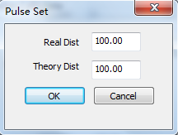

As the above picture indicate, draw a line in the software that the length is 100mm and cut. Measure the workpiece and the actual length of the line is 90mm, and input the values, the system will calculate the pulse unit automatically.

2.6.2.3 Z/U/W Axis

If the machine has automatic separation 2-head, the Z-axis should be used as 2-Head and the U-Axis can be used as feeding axis.

* + 1. **Laser Parameters**

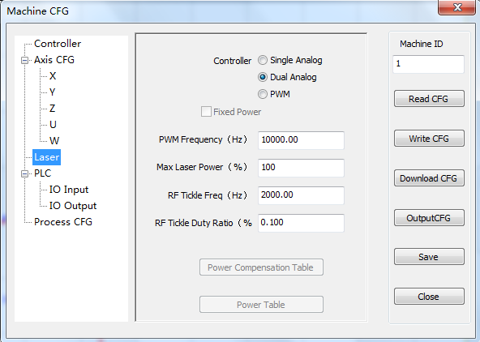

|  |  |  |  |
| --- | --- | --- | --- |
| Parameter | Respective value | | Description |
| Screw/Rack | Belt |
| Controller | Dual Analog | Dual Analog | Factory set is suggested. |
| PWM Frequency | 10000 | 10000 | Factory set is suggested. Effective in PWM mode |
| Max Laser Power | 100 | 100 | Factory set is suggested. |
| RF Tickle Freq | 2000 | 2000 | Factory set is suggested. Effective in PWM mode |
| RF Tickle Duty Ratio | 0.1 | 0.1 | Factory set is suggested. Effective in PWM mode |

* + 1. **PLC Configuration**

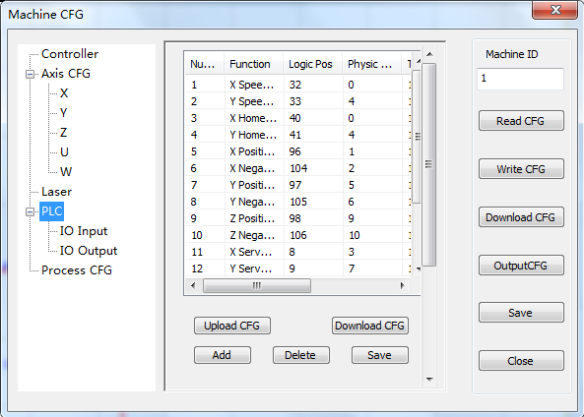

MPC95** series controller exists in this setting, other types of controller without PLC function, usually this part of the factory default configuration.

* + 1. **Process Parameters**

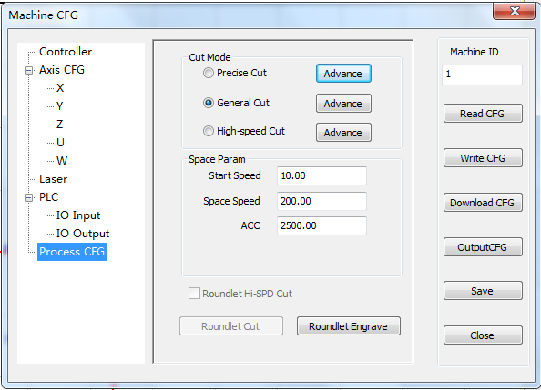

Space Param:

|  |  |  |  |
| --- | --- | --- | --- |
| Parameter | Respective value | | Description |
| Screw/Rack | Belt |
| Start Speed | 10 | 10 | Factory set is suggested. |
| Space Speed | 100 | 400 | Factory set is suggested. |
| ACC | 500 | 1000 | Factory set is suggested. |

2.6.5.1 Advanced Cutting Parameters

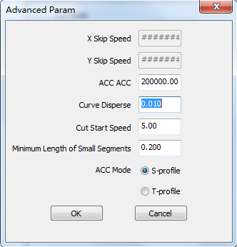

Factory set is suggested.

2.6.5.2 Engraving Advanced Parameters

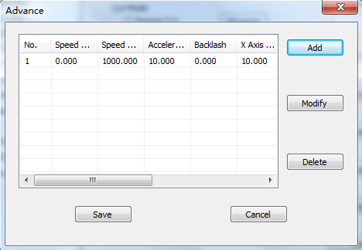

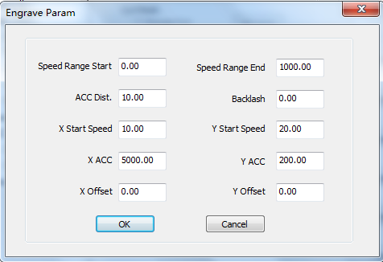

Speed Range Start: set the start point of the speed section.

Speed Range End: set the end point of the speed section.

ACC Dist: set the distance between the laser head and the working speed from the take-off speed. The value is too small will lead to engraving dislocation, too general assembly to reduce processing efficiency.

Backlash: this value is used to compensate the mechanical backlash. If you find the edge of the engraving is not neat, you can "reverse gap" to set a value, the value can be positive, the specific method of "5.5 laser engraving reverse clearance debugging method".

X Start Speed: engraving laser scanning head movement of the initial speed, the value of the General Assembly led to engraving dislocation, too small will reduce the processing efficiency.

X ACC: setting the acceleration of the laser head from the take-off speed to the operating speed.

Y Start Speed: set the maximum speed of the laser head movement when the Y axis is advancing. This value is too general to cause the machine to vibrate.

Y ACC: setting the acceleration of the Y axis from the take-off speed to the operating speed.

X Offset: this parameter can only be used for servo motors. When the servo motor is selected, the engraving position and the cutting position will be offset, this value is used to compensate for the engraving of the X axis misalignment.

Y Offset: this parameter can only be used for servo motors. When the servo motor is selected, the engraving position and the cutting position will be offset, this value is used to compensate for the engraving of the Y axis misalignment. Click "add" to set different processing parameters according to different speed range.

* + 1. **Open CFG File**

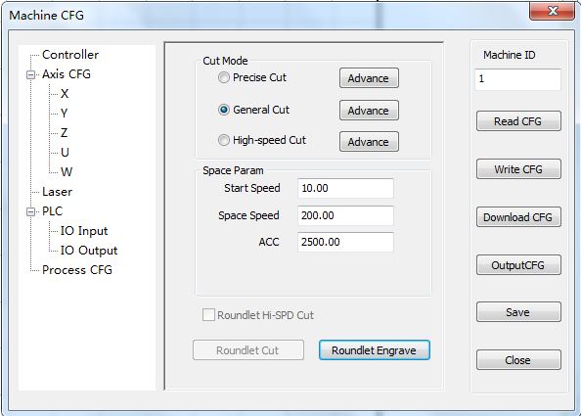

Read CFG:In the controller and the software properly connected, the read parameters, the parameters can be uploaded to the end software configuration file in the controller, for subsequent use, software is usually re installed on the PC terminal after the need for a read operation parameters, to ensure the normal use of the following.

Write CFG:Download the software parameter file to the controller

Download CFG:Click the button, select the file you want to download, click on the "click" to download the file. Mainly used to reinstall the software or the controller parameters have been modified using the function of artificial right recovery scenarios, recommends that customers will be *.INI, PLC.PRG, PLC.CFG in the purchase of equipment for these file backup. Some models only *.INI files.

Output CFG:Click the output configuration file, the software parameters to save a *.INI file to backup the subsequent use

Save:Save the modified parameters to the current computer for download.

Close:Don’t save this parameter modification.

## Version Check and Upgrade

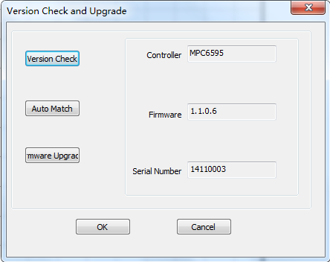

Control the card first and make sure that the computer is connected properly.

Version Check: Click on the "version" button, the system will display the controller and the library version information.

Firmware Update: Click on the "firmware upgrade" button, the system will automatically upgrade the controller to the latest version (please ensure that the software installation package for the latest version).

Be Careful： Firmware upgrade process, if the power failure will lead to upgrade failure, you must use the U disk upgrade can be restored to normal.

Key Restore: The machine parameters of the control card are restored to the factory value. This function can only take effect if the machine parameters are backed up. PAD can also be completed in a key to restore the operation.

## Description of status bar

|  |  |
| --- | --- |
| Icon Form | Description |
|  | The coordinate of the mouse |
| 003 | The communication state of PC and the controller. |

# Appendixes

## Quick Operation

* + 1. **Click Right Button of Mouse**

Clicking right button of mouse will enable and pop-up a quick operation box in below three states.

In the blank drawing area:

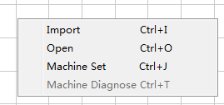

In the graph:

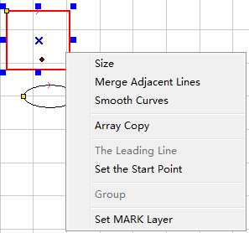

In the blank area when graph exists:

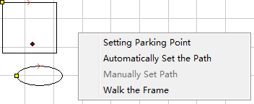

* + 1. **Ctrl+A**

Select all the graph in the drawing area.

* + 1. **Ctrl+Y**

Move the selected graph to the center of the drawing area.

Without selecting any graphics, the whole graph will be moved to the center of the drawing area.

## Cutting not sealing

* + 1. **Change option of auto sort**

As following, check the “Backlash Optimize” option.

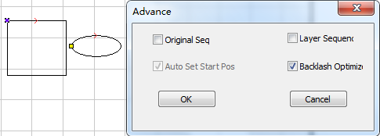

Checking this option will increase space distance.

* + 1. **Set Over Lap Length**

As following, input proper value in “Over Lap Length”.

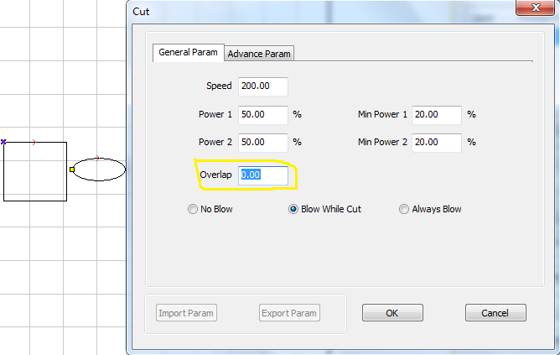

* + 1. **Set backlash**

As following, Input proper backlash value of the X and Y axis.

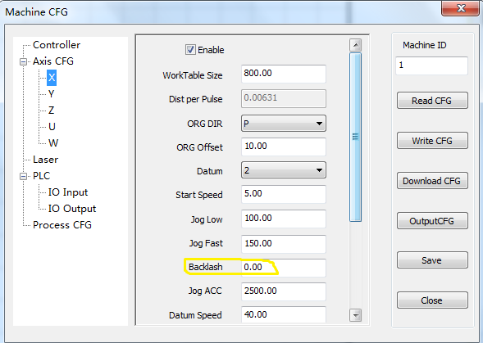

## Backlash Adjustment in Engraving

In engraving of high speed, burr may appear as below.

d

There is Backlash Compensation set in the Engrave Set of the Machine CFG. The backlash can be negative or positive value. Change the engrave step to 2mm, backlash 1mm, and start processing. If d increase, change it to a negative value; if d decreases, increase the number. Gradually d will near 0 after several adjustments. The value of the Backlash Compensation differs from different speed; you should set it according to different speed range.

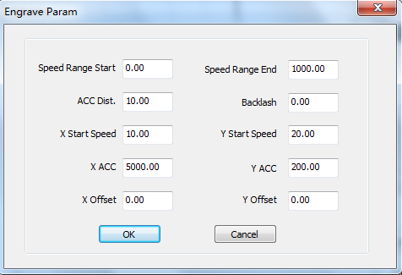

## FQA

* + 1. **PLT figure can’t be engraved**

The graph is unclosed or overlapped. Please use the “Check Data” tool to check if there are such occasions.

* + 1. **Size of the output of engrave/cut is not the same with the graphics**

Please adjust the “Pulse Unit”.

* + 1. **When engraving, the edge is not in order**

It is mainly caused by the backlash. You can adjust it as follow:

* + - * 1. Draw a rectangle, set the 0.5mm in “Laser Engrave” and “Engrave Step”. Theoretically, the engrave result will be ok, that is, edges of the odd lines are in order and edges of the even lines are in order. But odd lines and even lines may not be in order.
        2. Open “Set Engrave Options”, there are different processing parameters for different speed range. But set values in the “Backlash” are all 0. You can set the value according to the actual situation, both negative and positive.
        3. If you require a better engrave result, choose one direction laser on. Uncheck the “Bi-Dir” will do. But this will decrease the process efficiency.
    1. **Axis doesn’t move**

Set direct voltage 5V by a multimeter, measure the voltage between PUL and GND. Take Y-axis as an example. Press up or down button, the normal value is about 2.8V. If it is not, controller is damaged. Please change controller. If it is, step on.

Change the output terminals of the two drivers, and press up or down button. If X-axis is right, then Y-axis motor is damaged. Please replace Y-axis motor. If X-axis does not move, then Y-axis driver is damaged. Please replace Y-axis driver.

* + 1. **Axis can only move to one direction**

Set direct voltage 5V by a multimeter, measure the voltage between DIR and GND. Take X-axis as an example. Press left and then right button to see if there are changes of the voltage (higher than 2.8V or lower than 0.8V). If not, the controller is damaged. Please replace it. If yes, check if the driver is ok. Version description:

1. Jan, 2017 V0.1 New